 |  | Stoddard County Ambulance/December Issue
 | Frontline Scoop
Chuck Kasting, Director |  |  |  |  |  | (573)-624-4528  CKASTING@STODDEMS.COM
Birthdays and Anniversaries  DECEMBER BIRTHDAYS  - David Jones, EMT-B  - Celina Adams, Admin Assistant  - JT Putnam, EMD  - Susan Buckner, EMT-P  - Corbin Strong, EMT-B  - Austin Teichman, EMT-P, FCP  - Autumn Strickland, EMT-P  JANUARY BIRTHDAYS  - Jordan Robinson, EMT-P  - Alex Tuer, EMT-P  - Jennifer Caldwell, EMT-B  - Courtney Cantrell, EMT-B  - Pheonix Davidovich, EMT-B  DECEMBER “SCAD” IVERSIARIES  - Justice Lewis, EMT-B 1 year  - Kaysen Dill, EMD, CTO 3 years  JANUARY “SCAD’ IVERSIARIES  - JACOB BORDERS, AEMT  - JARRED HARGROVE, EMT-P  - SARAH MOORE, EMT-P |  |  |  |  | Welcome to the third issue of the Frontline Scoop!  We hope you all had a wonderful holiday season with your friends and family! We are looking forward to what the New Year will bring!  Ringing in the New Year is a cause for celebration, for spending time with friends and family, and for offering happy New Year wishes.  On the road to success, the rule is always to look ahead. May you reach your destination and may your journey be wonderful. Happy New Year from Stoddard County Ambulance. |  |  |  | YEAR END CALL TOTAL  EMS-4,586  FIRE-311  LAW-2,445  *Callers directly dialing 911  Home for the Holidays  Home for the Holidays is a service the Ambulance provides to county residents residing in nursing homes that are unable to provide transportation for themselves to “get home for the holidays.” This project was a success again this year and we look forward to continuing to offer this to the community in the years to come.
 |  |  |  |  | UPCOMING EVENTS  Jan.18 BLS CPR Class  Jan. 22nd ACLS Renewal Course |  |  |  | “WE BELIEVE THAT ALONE WE ARE POWERFUL AND TOGETHER WE ARE UNSTOPPABLE”

 | FRONTLINE SCOOP
EMPLOYEE SPOTLIGHT |  |  | Every month, peers nominate a “spotlight employee.”  For the month of December that employee was Sara Wheetley.  Sara oversees accounts payable and has been with SCAD since 2019.  Sara loves the family atmosphere at SCAD. She always has a smile on her face and her office door is always open for a chat. We appreciate all Sara does for the district. |  |  | 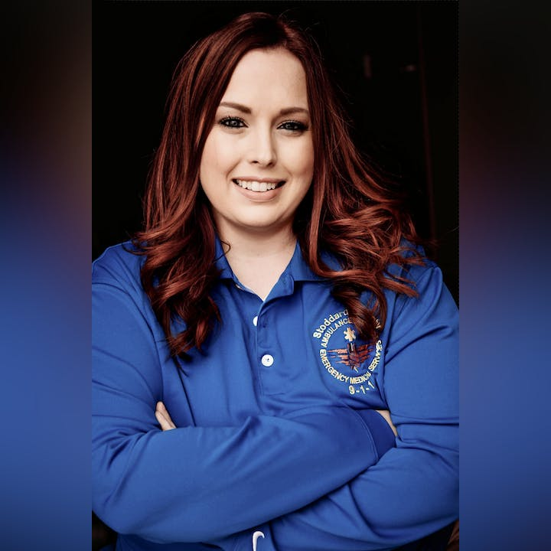
Charity 5k Run/Walk |  |  | Approved in the December board meeting. This charity 5k will be held in March 2024.  All money raised through sponsors and registration fees, will be donated to Stoddard County Childrens Home.  Keep a look out on the website and Facebook page for more information. |  |  |  | Christmas Brunch 2023  Every year, the staff and invited guests have brunch before Christmas. This is a chance to come together and enjoy a good meal and conversation with those we might not see during the holiday.  This year was a success with the classic breakfast foods cooked by our very our crews and members of command staff.  We look forward to next year!  Stoddard County Ambulance Website  stoddems.com  Here you will find photos, district events and public information.

